**PROJECT REPORT**

**ON**

**Online Placement Agency**

**Carried Out at**

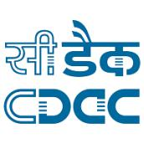

**CENTRE FOR DEVELOPMENT OF ADVANCED COMPPUTING**

**ELECTTRONIC CITY, BANGALORE**

**UNDER THE SUPERVISION OF**

**Mr. Harshvardhan Sir**

**C-DAC Bangalore**

**Submitted By**

**Ankur Yadav (220950120030)**

**Arvind Chandrakar (220950120038)**

**Ashish Verma (220950120042)**

**Dolly Teotia (220950120069)**

**Richa Sharma (220950120147)**

**PG DIPLOMAA IN ADVANCED COMPUUTING,**

**C-DAC, BANGALORE**

**CANDIDATE’S DECLARATION**

We hereby certify that the work being presented in the report entitled **Online Placement Agency**, in partial fulfillment of the requirements for the award of PGDiploma Certificate and submitted in the department of PG-DAC of the C-DAC Bangalore, is an authentic record of our work carried out during the period, 18th February 2023 to 15th March 2023 under the supervision of **Mr. Harshvardhan,** C-DAC Bangalore. The matter presented in the report has not been submitted by us for the award of any degree of this or any other Institute/University.

**(Name and Signature of Candidate)**

Ankur Yadav (220950120030)

Arvind Chandrakar (220950120038)

Ashish Verma (220950120042)

Dolly Teotia (220950120069)

Richa Sharma (220950120147)

**Counter Signed by**

--------------------

**ACKNOWLEDGMENT**



We take this opportunity to express our gratitude to all those people who have been directly and indirectly with us during the competition of this project. We pay thanks to Mr. Harshvardhan Sir who has given guidance and a light to us during this major project. His versatile knowledge about this project has eased us in the critical times during the span of this Final Project. We acknowledge here out debt to those who contributed significantly to one or more steps. We take full responsibility for any remaining sins of omission and commission.

Ankur Yadav (220950120030)

Arvind Chandrakar (220950120038)

Ashish Verma (220950120042)

Dolly Teotia (220950120069)

Richa Sharma (220950120147)

**CERTIFICATE**



This is to certify that the work titled **Online Placement Agency** is carried out by Ankur Yadav (220950120030), Arvind Chandrakar (220950120038), Ashish Verma (220950120042), Dolly Teotia (220950120069), Richa Sharma (220950120147), bonafide students of Diploma in Advanced Computing and Diploma IT Infrastructure, Systems and Security of Centre for Development of Advanced Computing, Electronic City, Bangalore from 18th February 2023 to 15th March 2023. The Course End Project work is carried out under my direct supervision and 80% completed.

**Mr. Harshvardhan**

Name of Supervisor

C-DAC #68, Electronic City,

Bangalore - 560100, India

**ABSTRACT**



The aim of this project is to develops an online search portal for the Placement of Job Seekers. The system is an online application that can be accessed throughout the organization and outside as well with proper login provided. This system can be used as an Online Job Portal for the Placement Dept of the college to manage the student information with regards to placement. User sign ups and create there profile. Recruiters/Company representatives logging in may also access/search any information put up by Students. The project has been planned to be having the view of distributed architecture, with centralized storage of the database. The application for the storage of the data has been planned. Using the constructs of MySQL Server and all the user interfaces have been designed using the Java Spring boot technologies. The database connectivity is planned using the “SQL Connection” methodology. The standards of security and data protective mechanism have been given a big choice for proper usage. The application takes care of different modules and their associated reports, which are produced as per the applicable strategies and standards that are put forwarded by the administrative staff.

**TABLE OF CONTENT**



**CHAPTER 1. INTRODUCTION**

1.1 Purpose

1.2 Product scope

**CHAPTER 2. LITERATURE SURVEY**

**CHAPTER 3. SOFTWARE REQUIREMENT SPECIFICATION**

3.1 Server Side

3.2 Client Side

**CHAPTER 4. SYSTEM DESIGN**

4.1 Model Design

4.2 Study Of The Design

**CHAPTER 5. UML DIAGRAM**

5.1 Admin

5.2 Employer

5.3 User

**CHAPTER 6. OUTPUT SCREEN**

**CHAPTER 7. CONCLUSION**

**CHAPTER 8. REFERENCES**

**CHAPTER 1**

**INTRODUCTION**



As we know that searching of jobs is so difficult in proficient areas, so this portal is developed to providing the simple and good job searching. With the help of this portal easily the job seeker can submit their resume and get the lot of opportunity of the job related to their profile. And by this website the companies or employer can also find the good and well profiled resume.

**1.1 Purpose**

The Online Placement Agency is a job portal system that is to be developed, provides the members with jobs information, online applying for jobs and many other facilities. This system provides service to the job applicants to search for working opportunities.

This Portal will allow job provider to establish one to one relationship with candidates. It will primarily focus on the posting and management of job vacancies. This system is designed such that ultimately all vacancies will be posted online and would offer employers the facilities to post their vacancies online. It helps to review and manage the resulting applications efficiently through the web. Employer can also find the resume according to key skill in very less amount of time.

**1.2 Product Scope**

As of Indian market, there is ample opportunities for the job portal sites, as more and more number of educated and skilled young people are coming out each and every year. Also, as the growth rate of India is zooming to be at a healthy rate over 7%, so it is boom time for corporate also. So, a greater number of lucrative careers will be available for the job seekers. So, it is now the right period for the job portal sites to think out of the box, and to make most of the opportunities available.

**CHAPTER 2**

**LITERATURE SURVEY**



Job Procurement: Old and New Ways Job seeking usually involves different ways to look for jobs such as through personal contacts, direct telephone calls to employers, job agency office, scanning online job listings, etc. Before the Internet, became widely uses as a method of seeking jobs, jobseekers spent a lots of time using various methods to look for job openings. Today, jobseekers use online methods which are very convenient and save a lot of time. Galanaki lists the following methods to be the traditional (old) ways for recruitment:

1) Employment recruitment agencies

2) Job fairs

3) Advertising in the mass media such as newspapers

4) Management Consultants

5) Advertisement in television and radio

6) Existing employee contacts

7) Schools colleges or universities students services department

8) Workers or professional referrals

These old job seeking methods are too slow, stressful, challenging and also lack quality. In addition, the applicants have to consider the cost and the amount of time to get the information they need, and other preparations they have to make. Finding all available job vacancies is a main step at in the job-seeking process. The Internet is now a powerful tool that jobseekers can use. Today, there are many sites that advertise job positions to be filled by people with certain skills in various fields. The Internet plays an important role in the area of human resource planning and development. Most planning and development organizations are now using computer technology and the Internet for staff recruitment. It should be noted that although the Internet has facilitated the process of job-seeking, it has not replaced the traditional methods, completely. Importance of Job Portals In the age of technology, the Internet has become the main source of information for jobseekers. Large corporations, Institutions, and universities include information on career Prospects on their websites. According to a survey, 70% of the workforce uses websites or portals on the Internet to Search for jobs in France. These websites or portals provide search engine to access information on job opportunities.

**CHAPTER 3**

**SOFTWARE REQUIREMENT SPECIFICATION**



**SERVER SIDE :-**

* **Processor:** Intel® Xeon® processor 3500 series
* **HDD:** Minimum 500GB Disk Space
* **RAM:** Minimum 4GB
* **OS:** Windows 10
* **Database:** MySQL

**CLIENT SIDE (minimum requirement) :-**

* **Processor:** Intel Dual Core
* **HDD:** Minimum 80GB Disk Space
* **RAM:** Minimum 2GB
* **OS:** Windows 7

**CHAPTER 4**

**SYSTEM DESIGN**



## 4.1 Model Design

The model that is basically being followed is the WATER FALL MODEL, which states that the phases are organized in a linear order. First of all the feasibility study is done. Once that part is over the requirement analysis and project planning begins. If system exists one and modification and addition of new module is needed, analysis of present system can be used as basic model.

The design starts after the requirement analysis is complete and the coding begins after the design is complete. Once the programming is completed, the testing is done. In this model the sequence of activities performed in a software development project are : -

* + - Requirement Analysis
    - Project Planning
    - System design
    - Detail design
    - Coding
    - Unit testing
    - System integration & testing

Here the linear ordering of these activities is critical. End of the phase and the output of one phase is the input of other phase. The output of each phase is to be consistent with the overall requirement of the system. Some of the qualities of spiral model are also incorporated like after the people concerned with the project review completion of each of the phase the work done.

WATER FALL MODEL was being chosen because all requirements were known beforehand and the objective of our software development is the computerization/automation of an already existing manual working system.



**Requirements Engineering**

**Design**

**Programming**

**Maintenance**

**Process**

**Integration**

**Product**

**Product**

**Delivery**

**Input Output**

**Delivered Software Product**

**Integrated Software Product**

**Executable Software Modules**

**Design Specification**

**Requirements Specification**

**Communicated Requirements**

**Changed Requirements**

##### Fig: Water Fall Mode



**4.2 Study Of The System**

**GUI’S**

In the flexibility of the uses the interface has been developed a graphics concept in mind, associated through a browses interface. The GUI’S at the top level have been categorized as

1. Administrative user interface
2. The operational or generic user interface

The administrative user interface concentrates on the consistent information that is practically, part of the organizational activities and which needs proper authentication for the data collection. The interfaces help the administrations with all the transactional states like Data insertion, Data deletion and Date updation along with the extensive data search capabilities.

The operational or generic user interface helps the users upon the system in transactions through the existing data and required services. The operational user interface also helps the ordinary users in managing their own information helps the ordinary users in managing their own information in a customized manner as per the assisted flexibilities.

**NUMBER OF MODULES**

The system after careful analysis has been identified to be presented with the following modules:

##### The modules involved are:

* + - Admin
    - Job Seeker
    - Job Provider
    - Notification
    - Search
    - Report
    - Authentication

**Admin**

In this module Admin will add all the qualifications, skill, experience, city, state, country and update and delete information about the job provider or job seeker he can also search for the job seeker and he can send mail to offer the job to job seeker and he can also see the jobs add by the job provider.

**Job Seeker**

In this module Job Seeker register him self and upload his resume and fill the profile give by admin and after login he will search for the job on various conditions and he can change his profiles and resume and he can apply for the jobs based on various conditions. He can see the response of the company and he can call the company person for the interview.

**Job provider**

In this module Job Provider register him self and his company and after login he will add new job and he can search for the job seekers on various condition and he can offer the job to job seeker according to the job profile and he can also see the response from the job seekers and send the mail.

**Notification**

In this module admin and job provider send the notification to the job seeker in the form of email.

**Reports**

This module contains all the information about the reports generated by the admin based on the particular job seeker, particular job provider, all job seeker and job provider, all jobs generated by the job providers.

**Authentication**

This module contains all the information about the authenticated user. User without his username and password can’t enter into the login if he is only the authenticated user then he can enter to his login.

**CHAPTER 5**

**UML DIAGRAM**



**Admin**

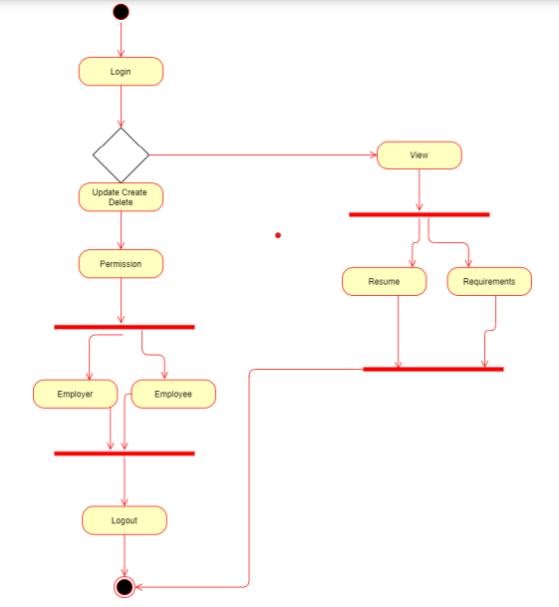

**Employer**

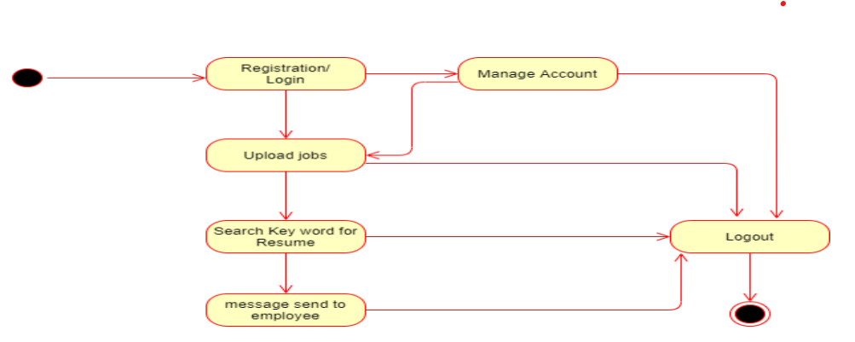

**User**

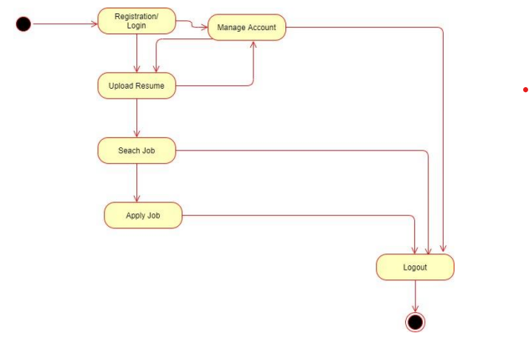

**CHAPTER 6**

**OUTPUT SCREEN**



Home Page

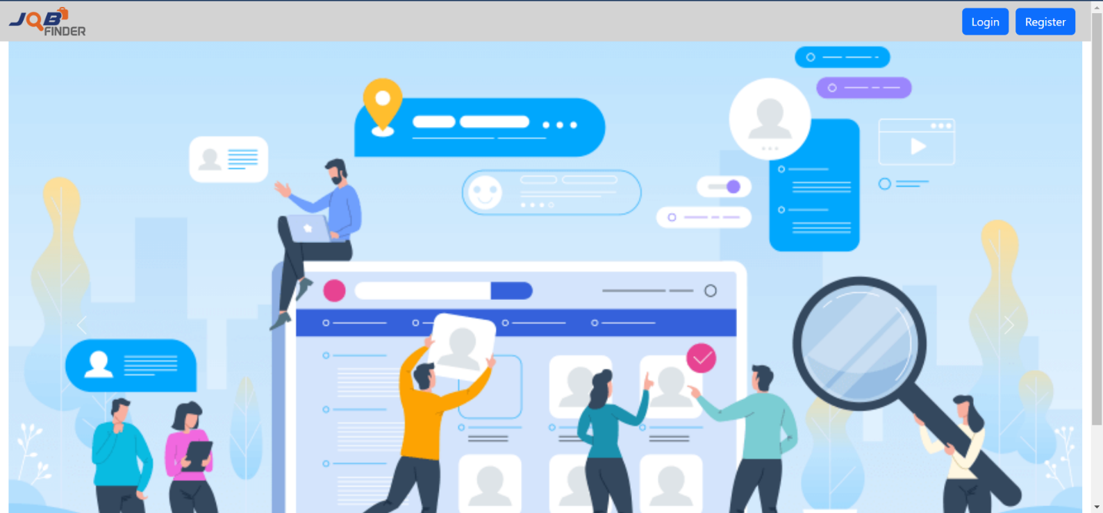

Sign Up Page

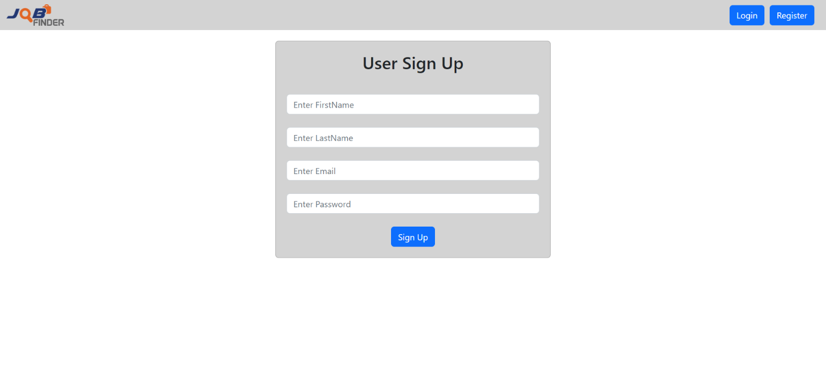

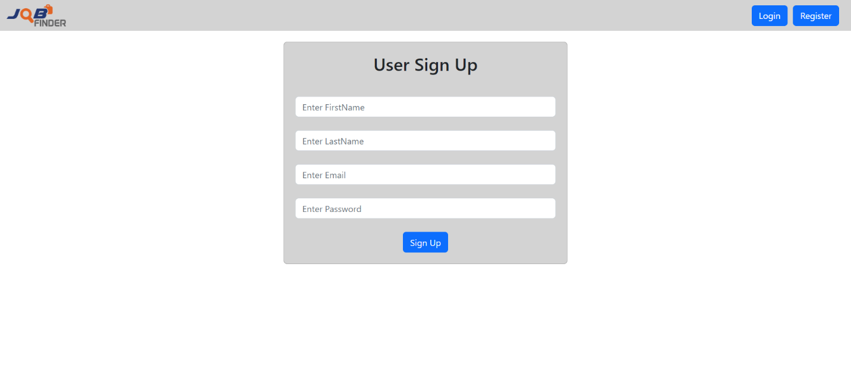

Login Page

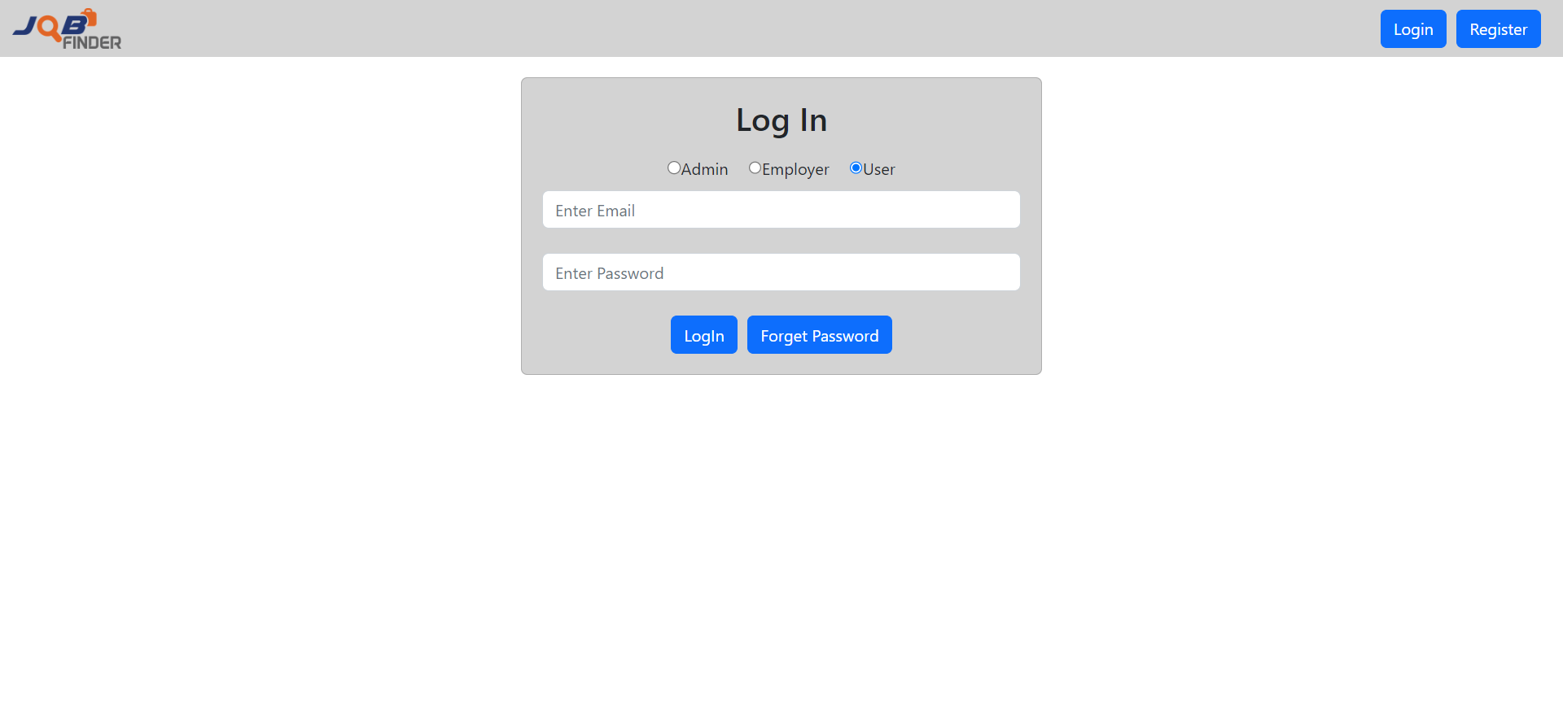

Login confirmation

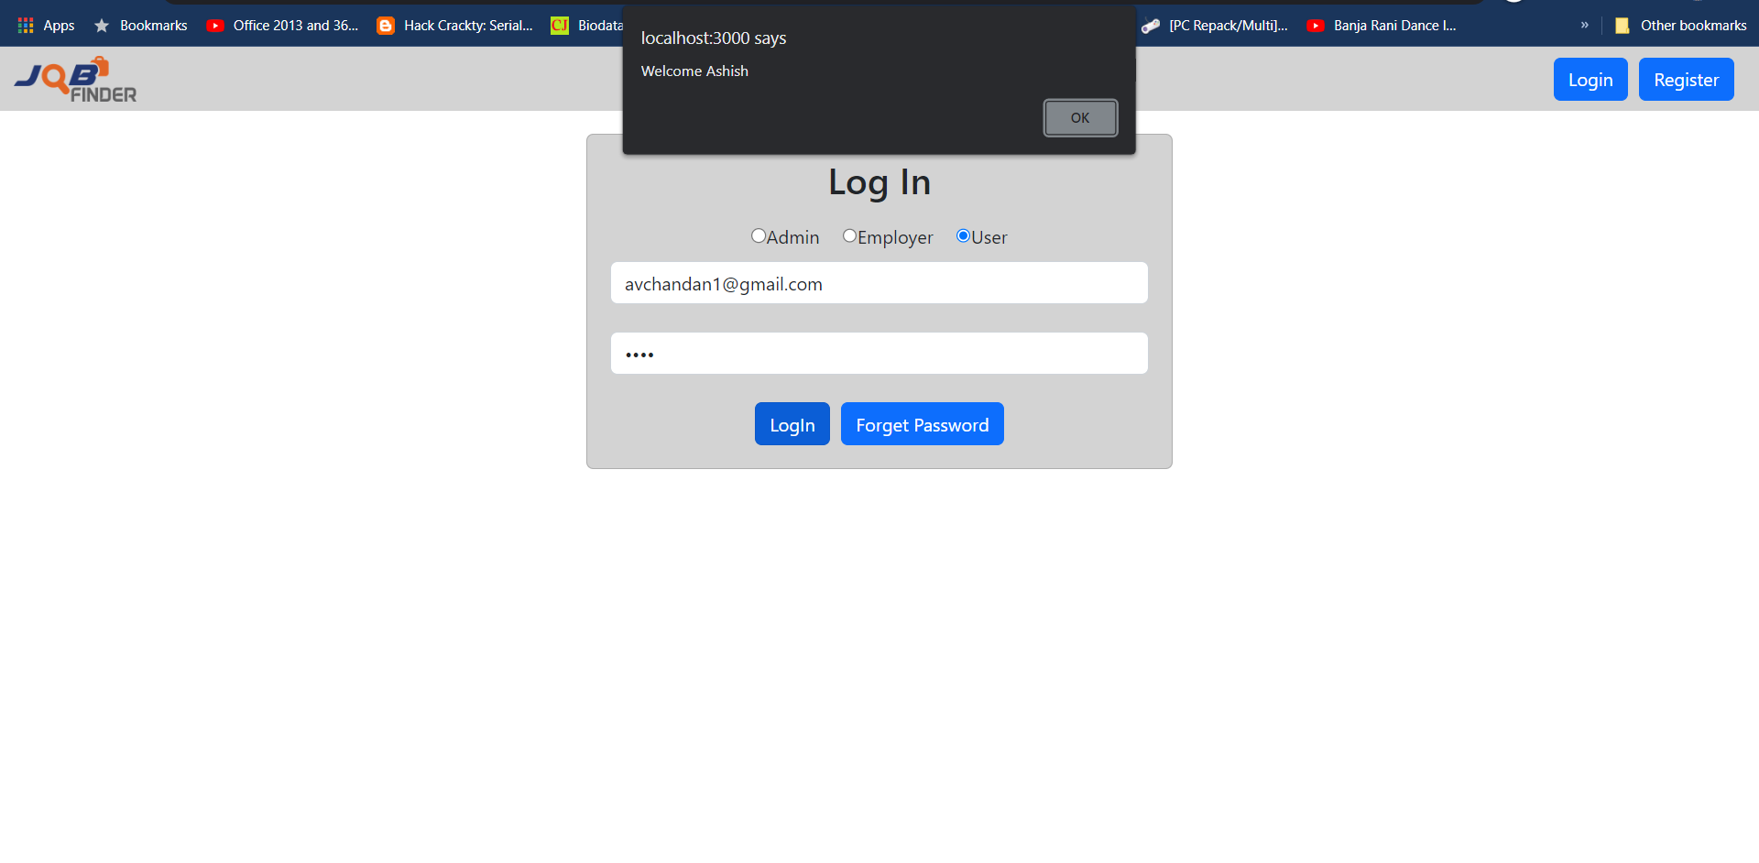

User Empty Dashboard

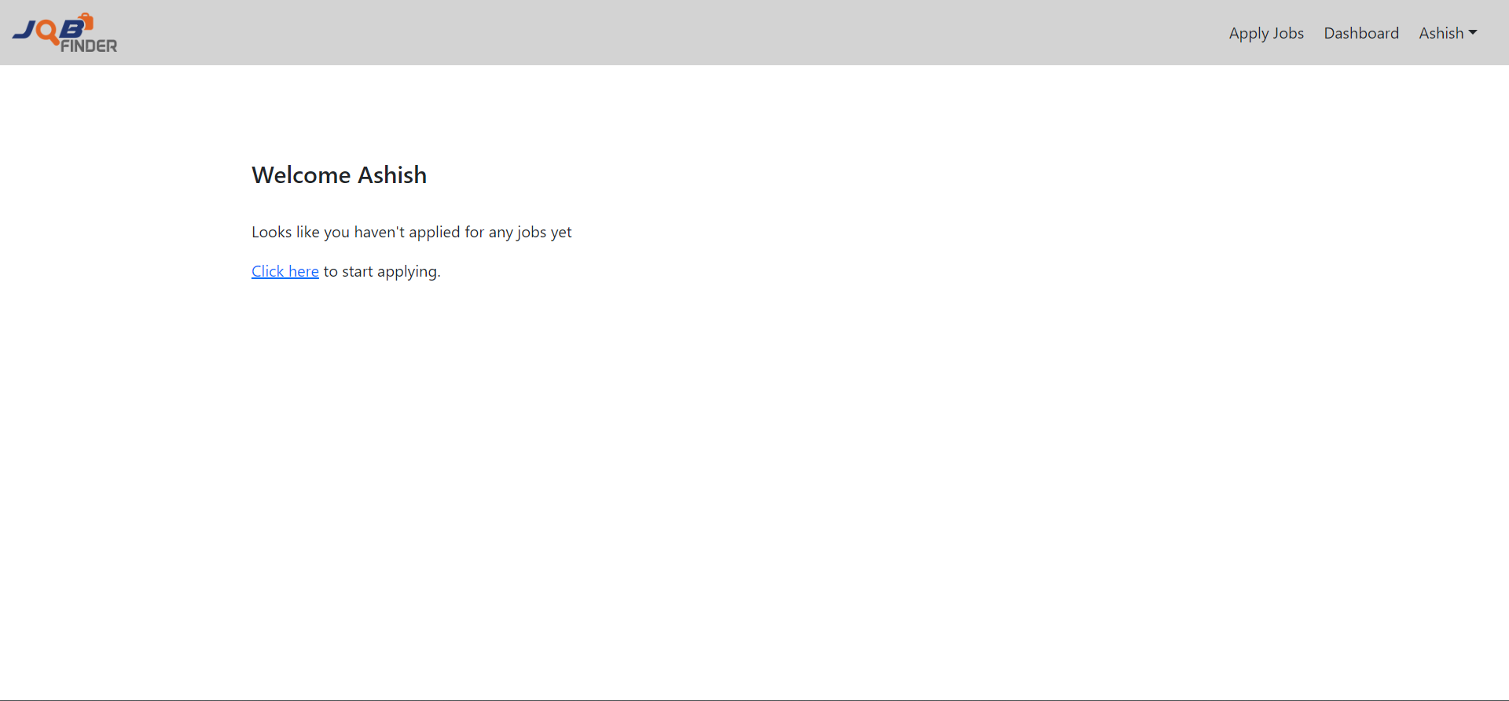

All Jobs List

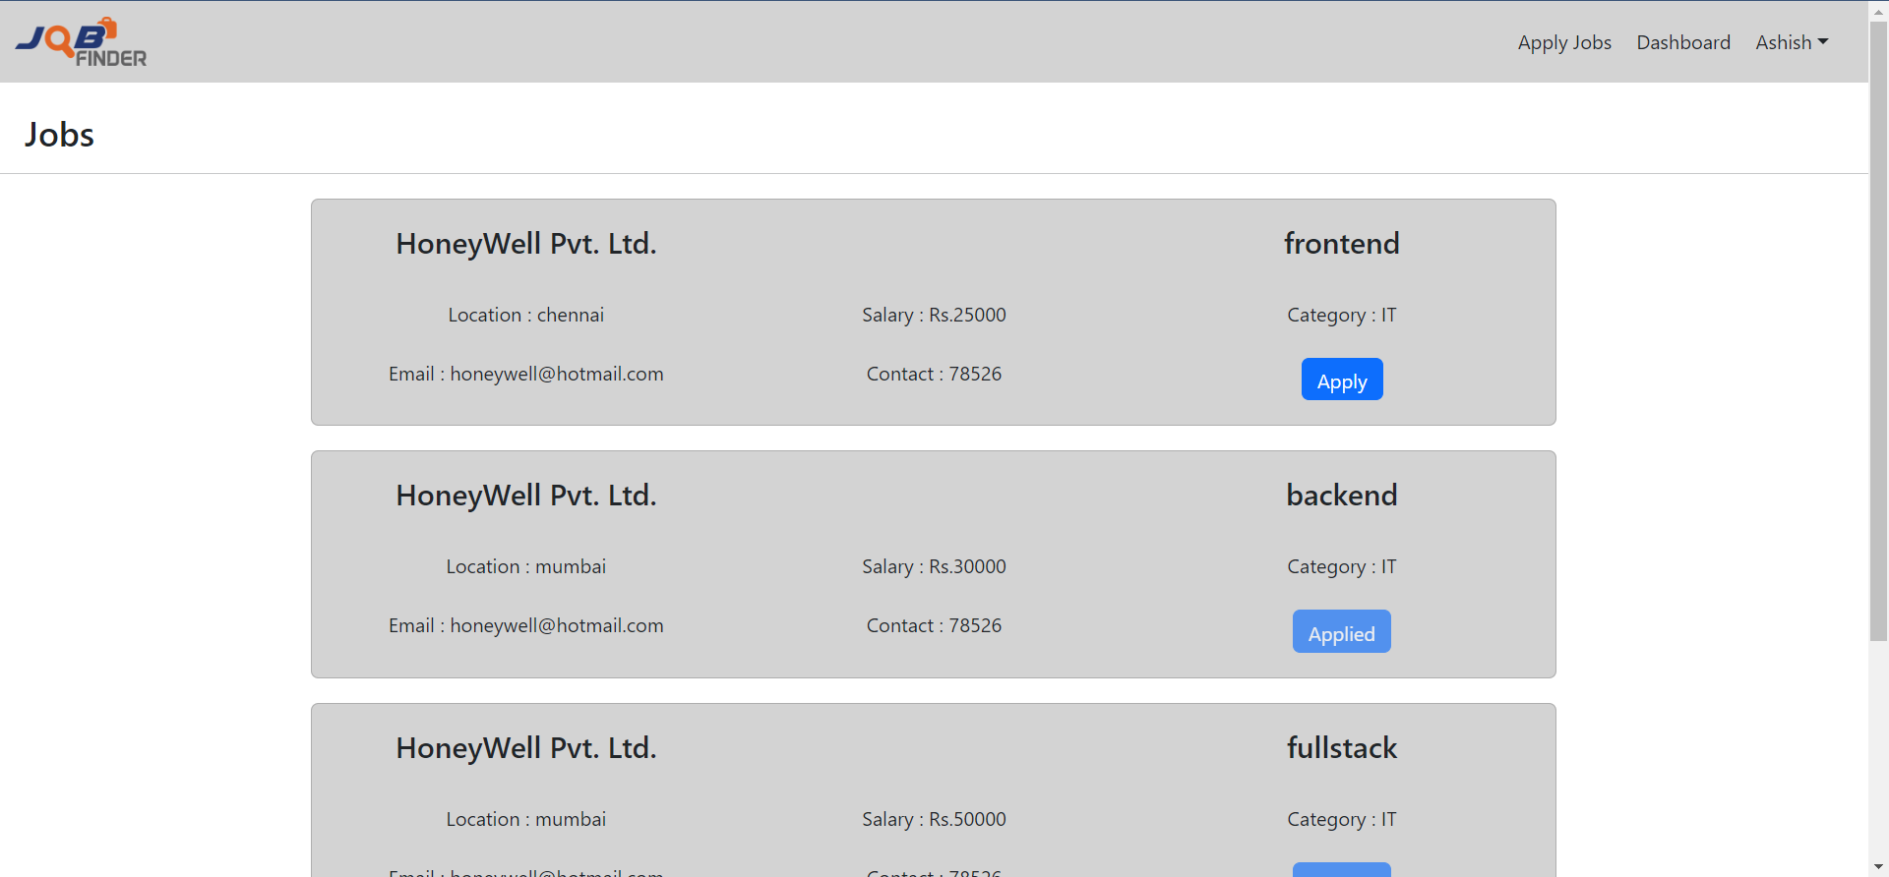

User Dashboard

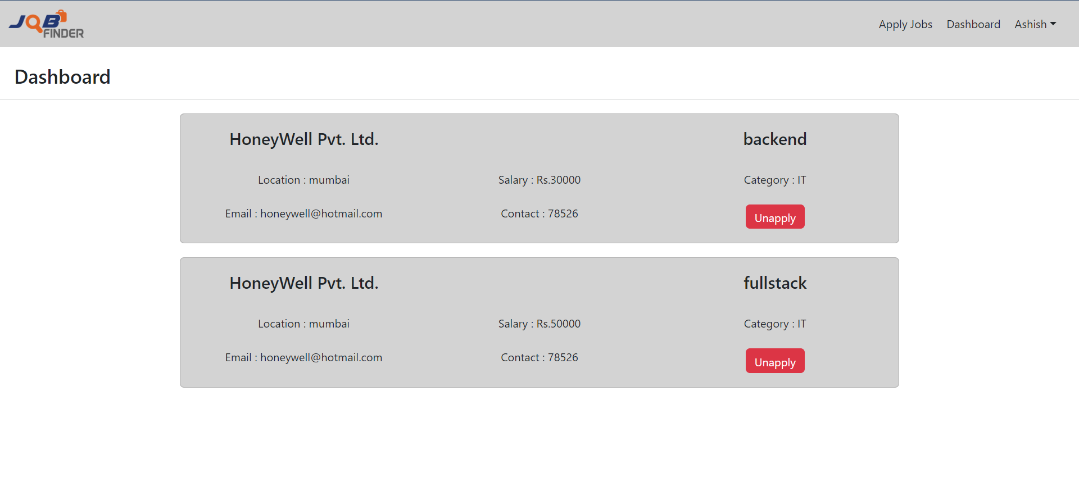

User Profile

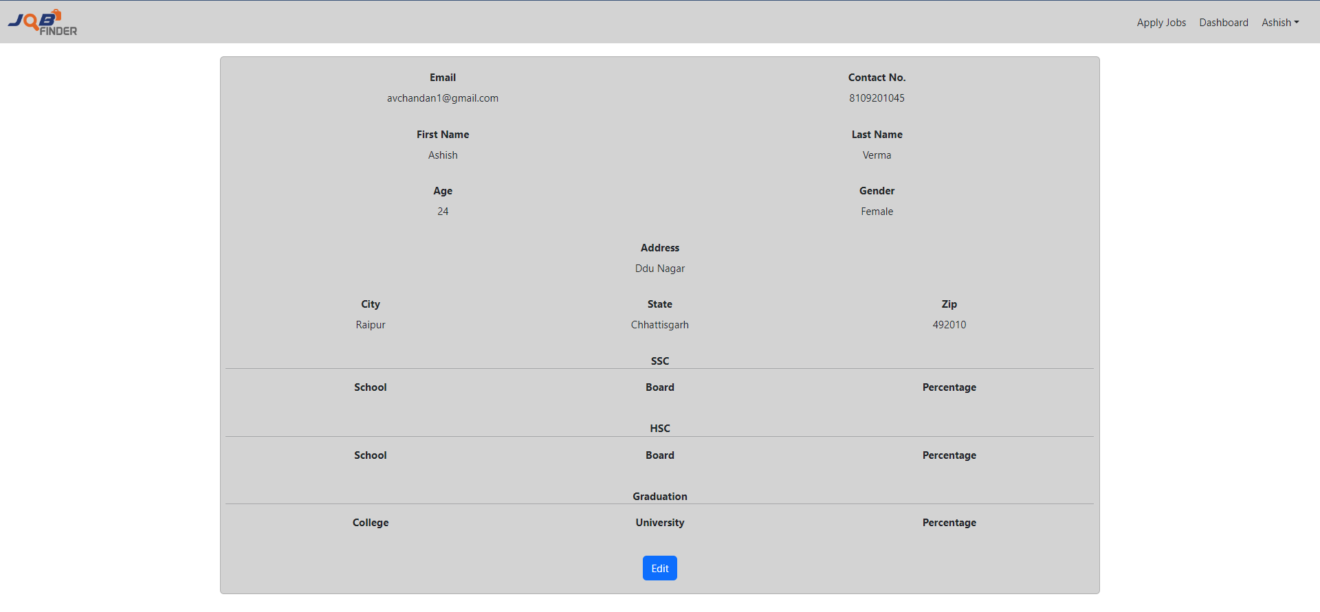

User Profile Edit

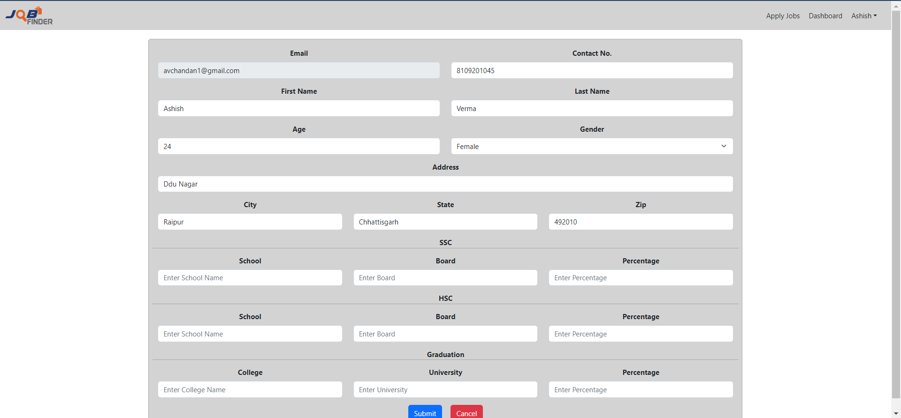

Logout confirmation

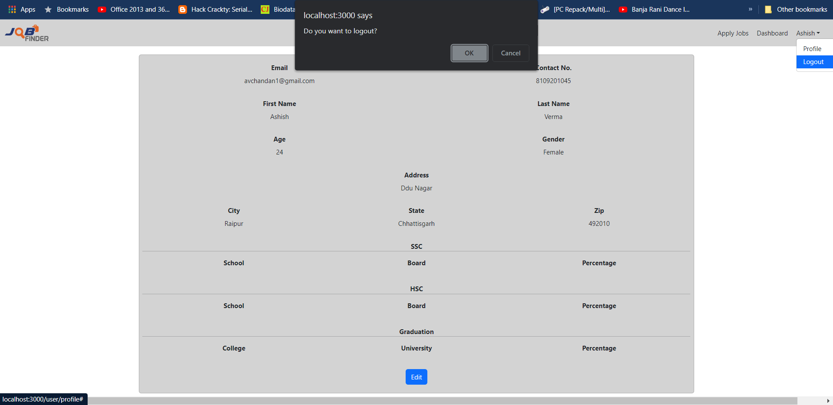

**CHAPTER 7**

**CONCLUSION**



It has been a great pleasure for me to work on this exciting and challenging project. This project proved good for me as it provided practical knowledge of not only programming in ASP.NET and VB.NET web based application and no some extent Windows Application and SQL Server, but also about all handling procedure related with **“ONLINE PLACEMENT AGENCY”.** It also provides knowledge about the latest technology used in developing web enabled application and client server technology that will be great demand in future. This will provide better opportunities and guidance in future in developing projects independently.

##### BENEFITS:

The project is identified by the merits of the system offered to the user. The merits of this project are as follows: -

* It’s a web-enabled project.
* This project offers user to enter the data through simple and interactive forms. This is very helpful for the client to enter the desired information through so much simplicity.
* The user is mainly more concerned about the validity of the data, whatever he is entering. There are checks on every stages of any new creation, data entry or updation so that the user cannot enter the invalid data, which can create problems at later date.

Sometimes the user finds in the later stages of using project that he needs to update some of the information that he entered earlier. There are options for him by which he can update the records. Moreover there is restriction for his that he cannot change the primary data field. This keeps the validity of the data to longer extent.

* User is provided the option of monitoring the records he entered earlier. He can see the desired records with the variety of options provided by him.
* From every part of the project the user is provided with the links through framing so that he can go from one option of the project to other as per the requirement. This is bound to be simple and very friendly as per the user is concerned. That is, we can sat that the project is user friendly which is one of the primary concerns of any good project.
* Data storage and retrieval will become faster and easier to maintain because data is stored in a systematic manner and in a single database.
* Decision making process would be greatly enhanced because of faster processing of information since data collection from information available on computer takes much less time then manual system.
* Allocating of sample results becomes much faster because at a time the user can see the records of last years.
* Easier and faster data transfer through latest technology associated with the computer and communication.
* Through these features it will increase the efficiency, accuracy and transparency,

##### LIMITATIONS:

* The size of the database increases day-by-day, increasing the load on the database back up and data maintenance activity.
* Training for simple computer operations is necessary for the users working on the system.

**CHAPTER 8**

**REFERENCES**



* [React Tutorial (w3schools.com)](https://www.w3schools.com/react/)
* [Learn Spring Boot | Baeldung](https://www.baeldung.com/spring-boot)
* [Spring Data JPA - Reference Documentation](https://docs.spring.io/spring-data/jpa/docs/current/reference/html/)
* [React – A JavaScript library for building user interfaces (reactjs.org)](https://reactjs.org/)
* Bootstrap · the most popular HTML, CSS, and JS library in the world. (getbootstrap.com)